Community Council Report
Llandow Ward
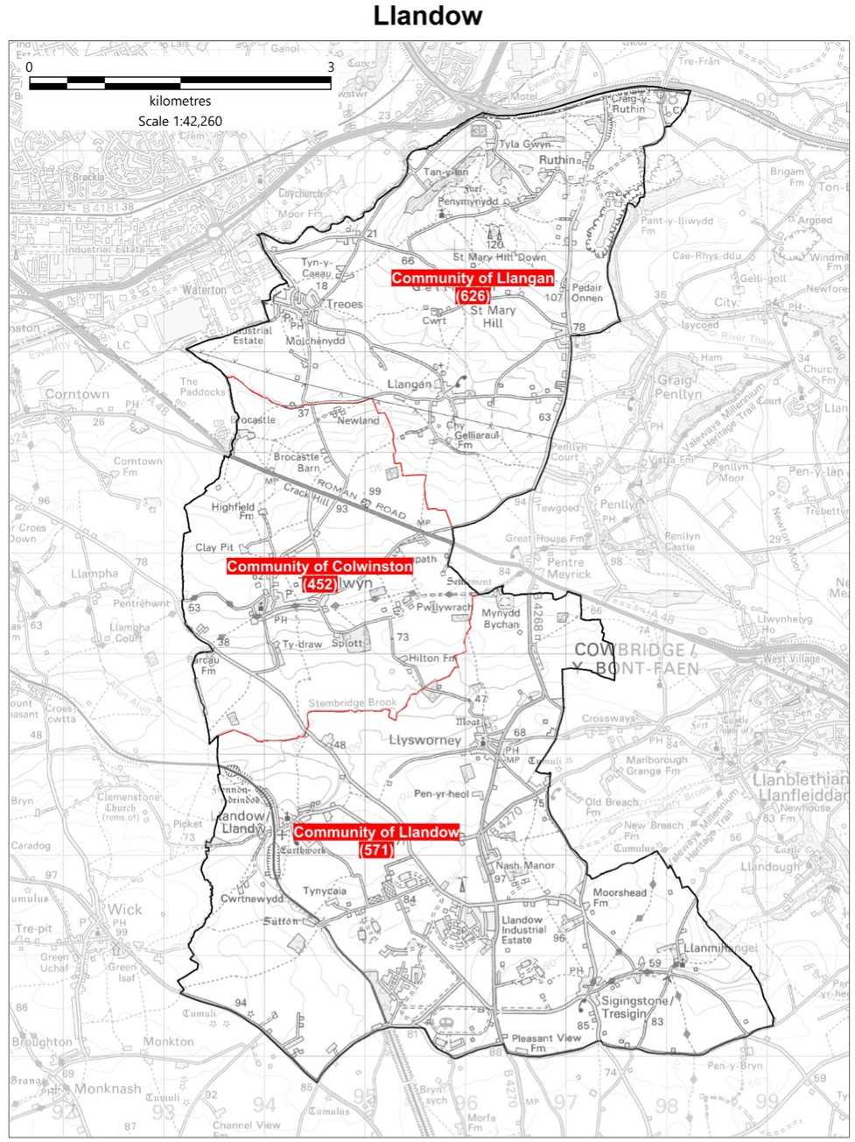
Cllr. Christine Cave email: cacave@valeofglamorgan.gov.uk

Date: May 2026 Report to the Community Councils (CC) in the Llandow Ward: Colwinston; Llandow, Llysworney, Sigingstone, Sutton and Llangan/Treoes and St Mary Hill.

Vale of Glamorgan Full Council meeting to April 2027

13th May, 13th July, 28th September, 7th December, 8th March, 26th April

Members of the Cabinet
Councillor L. Burnett (Executive Leader and Cabinet Member for Performance and Resources)
Councillor B.E. Brooks (Deputy Leader and Cabinet Member for Sustainable Places)
Councillor R.M. Birch (Cabinet Member for Education, Arts and the Welsh Language)
Councillor G. John (Cabinet Member for Leisure, Sport and Well-being)
Councillor S.D. Perkes (Cabinet Member for Public Sector Housing and Tenant Engagement)
Councillor S. Sivagnanam (Cabinet Member for Community Engagement, Equalities and Regulatory Services)
Councillor E. Williams (Cabinet Member for Social Care and Health)
Councillor M.R. Wilson (Cabinet Member for Neighbourhood and Building Services)

Cabinet meetings due to be held in May 2026. – 28th May

April 2026 Cabinet meetings:

30th April 2026 - HYBRID MEETING - AGENDA

PART I
1. Apologies for absence.
[View Minutes]
2. Minutes of the Meeting held on 16th April 2026.
[View Minutes]
3. To receive declarations of interest and the nature of such interests under the Council’s Code of Conduct.
[View Minutes]
References –
4. Task and Finish Review – Additional Learning Needs Resource Bases – Start Well Scrutiny Committee: 23rd March 2026.
[View Minutes]
5. Review of Pilot Leisure Activity at Cosmeston Country Park – Place Scrutiny Committee: 24th March 2026.
[View Minutes]
6. Quarter 3 Revenue Monitoring 2025/26 – Resources Scrutiny Committee: 25th March 2026.
[View Minutes]
7. Task and Finish Review – On Providing Greater Accessibility to Beaches in the Vale of Glamorgan – Extraordinary Place Scrutiny Committee: 1st April 2026.
[View Minutes]
8. HMRC Mileage Claims – Joint Consultative Forum: 20th April 2026.
[View Minutes]
Reports of the Cabinet Member for Public Sector Housing and Tenant Engagement –
9. Housing Kitchen, Wetroom and Bathroom Replacement Scheme 2025-26.
[View Minutes]
10. Housing 41-51a Main Street Retrofit Project 2026-27.
[View Minutes]
11. Disposal of Small Parcels of Housing Owned Land.
[View Minutes]
12. Any items which the Chair has decided are urgent (Part I).
PART II
THE PUBLIC AND PRESS MAY BE EXCLUDED FROM THE MEETING DURING CONSIDERATION OF THE FOLLOWING ITEM(S) IN ACCORDANCE WITH SECTION 100A(4) OF THE LOCAL GOVERNMENT ACT 1972.
Reports of the Cabinet Member for Public Sector Housing and Tenant Engagement –
13. Housing Kitchen, Wetroom and Bathroom Replacement Scheme 2025-26.
[View Minutes]
14. Housing 41-51a Main Street Retrofit Project 2026-27.
[View Minutes]

16th April 2026 - HYBRID MEETING - AGENDA
PART I
1. Apologies for absence.
2. Minutes of the Meeting held on 26th March 2026.
[View Minute]
3. To receive declarations of interest and the nature of such interests under the Council’s Code of Conduct.
[View Minute]
References –
4. Task and Finish Response Report: Leisure Services – Live Well Scrutiny Committee, 17th March 2026.
[View Minute]
5. Task and Finish Review on Countering Misinformation – Resources Scrutiny Committee, 25th March 2026.
[View Minute]

Reports of the Executive Leader and Cabinet Member for Performance and Resources –
6. Directorate Plans 2026/27: Year 2 Activities, Performance Measures and Performance Targets Supporting Delivery of Vale 2030.
[View Minute]
7. Cabinet Quarterly Report - Reporting Minutes of Joint Committees and Committees where the Vale of Glamorgan Council is an Active Participant.
[View Minute]
8. Cabinet Annual Strategic Forward Work Programme May 2026 to April 2027 and Cabinet Quarterly Work Programmes – January to March 2027 and April to June 2027.
[View Minute]
9. Local Growth Fund in Wales – Vale of Glamorgan.
[View Minute]
Report of the Cabinet Member for Public Sector Housing and Tenant Engagement –
10. Housing Support Grant Delivery Plan 2026-2029 and Annual Spend Plan 2026-27.
[View Minute]

Local Matters

- Colwinston/Llandow/Llangan – Matters raised in relation to training requirements and information following the Boundary Commission review of Town and Community Councils – The Commission has now published its Final Recommendations Report for the Electoral Arrangements in the Vale of Glamorgan. https://www.dbcc.gov.wales/reviews/01-26/vale-of-glamorgan-final-recommendations
- Colwinston/Llandow/Llangan – request made to the director of highways to make urgent repairs to the access road to the Llandow recycling centre – ongoing.
- Colwinston/Llangan/Llandow – Planning matter Lidl’s Llanmaes – Welsh Government have ‘called in’ and intend to hold a public enquiry – ongoing
- Colwinston - Adoption of the vines– (easements signed) waiting confirmation from Persimmon Homes - ongoing
- Colwinston – RLDP – information provided to members – ongoing
- Colwinston – empty property request for information - provided.
- Colwinston – RLDP proposed affordable housing – request made to planning department regarding changes to the settlement boundary response as follows: All of the proposed allocations (Vale wide), if adopted, would result in the change of settlement boundaries to incorporate those sites- as logically they would then be included. The recent consultation that ended on 11th March included these proposals, albeit if the RLDP were adopted, there would still need to be a Planning application for any development of that site. The link below takes you to the Settlement Boundary document, that formed part of the consultation, which shows all proposed changes to settlement boundaries, including but limited to proposed allocations. BP46 Settlement Boundary Review compressed.pdf
- Llandow – Sigingstone – planning reference 2021/00209/FUL - Land to the South West of Sigingstone - residential development of 10 dwellings and associated infrastructure works‘call in’ request made to Welsh Government – ongoing
- Llandow – Field water run off – meeting held by subgroup in November and agreed a full meeting will be held the 21st September 2026 – invitations sent out - ongoing
- Llandow – hedgerow removal and new entrance without planning permission raised with VoG planning department and enforcement team – planning application received for ‘Will’s Yard see https://www.valeofglamorgan.gov.uk/Documents/_Committee%20Reports/Cabinet/2026/26-03-26/Ref-from-GA-Corporate-Complaints-Support-Service-Improvement.pdf consultation stage - ongoing
- Llandow – Poor state of the play area in Llandow – meeting held with parks team in June – and again in August with the Play team. Play team attended Llandow CC meeting in December – no response heard since - ongoing
- Llandow – Sigingstone – clearing of the pond – meeting discussed several issues that are now connected with a wider area of possible ‘asset transfer’ proposals. Information provided regarding completion of the stage two – ongoing
- Llangan/Llandow – Speeding traffic and volume of traffic on the rural roads raised again with VoG - this is an ongoing issue
- Llangan – RLDP concerns raised with VoG planning department – ongoing
- Llangan – potholes reported and repaired along the stretch of road just before Llangan school to Ruthin.
- Llangan - Unresolved flooding issue in Treoes – reported – ongoing
- Llangan – Planning enforcement issue raised – ongoing.

Scheduled Meetings for May 2026 - All Meetings commence at 6.00 p.m. and will be held virtually unless otherwise stated

Council |  | Early Retirement/Redundancy (4.00 p.m.) | 21st May
Annual Meeting | 13th May | Licensing - Public Protection (10.00 a.m.) | 11th May
Cabinet (2.00 p.m.) | 28th May | Licensing - Statutory | 19th May
Scrutiny (Resources) |  | Licensing Sub
Scrutiny (Start Well) |  | Planning (4.00 p.m.) | 21st May
Scrutiny (Live Well) | 19th May | Public Rights of Way
Scrutiny (Place) | 26th May | Senior Management Appointment
Appeals |  | Standards
Governance and Audit |  | Trust
Community Liaison |  | Vale of Glamorgan Local Access Forum
Democratic Services (4.00 p.m.) |  | Voluntary Sector Joint Liaison
Investigating |  | Welsh Church Act Estate (4.00 p.m.)
Shared Regulatory Services Joint Committee
(10.00 a.m.)

